Chapter 6
Fungal reproduction

One of the reasons why fungi are so successful and therefore so ubiquitous in nature is due to their mode of reproduction: spores. Most species of fungi can produce spores in incredible quantities. The ability of fungi to produce so many spores increases the chance that at least some of them will land in a suitable environment where they can germinate and begin the process all over again.
Spores can be a result of sexual reproduction, involving meiosis and genetic recombination. Or they can be produced asexually, where genetic clones of the parent are produced via mitosis. Some fungi produce only sexual spores or only asexual spores (conidiospores), while others may be capable of both sexual and asexual spore production.
Spores also vary quite drastically in shape and size. As a matter of fact, spore shape/size/features/colors/staining-ability are often extremely useful tools in identifying fungi. Characteristics relevant to spore development on the reproductive part of the fungus can be another useful tool in identifying unknown fungi.
Similar to the importance of flower and reproductive morphology for identifying plants, the reproductive parts of fungi often reveal evolutionarily-conserved, diagnostic features that are more readily differentiated than vegetative tissue. The characteristics of reproductive tissue are less likely than vegetative tissue to change drastically through evolutionary time. This is likely because the precision of reproduction, and therefore its relevant tissues, are so fundamental to survival of a species across generations. Vegetative structures, on the other hand, may be more flexible to change in the face of shifting selective pressures due to the wider range of acceptable functionality of such tissues. Therefore, vegetative characters often appear similar, even among relatively unrelated organisms; an artifact of convergent evolution.

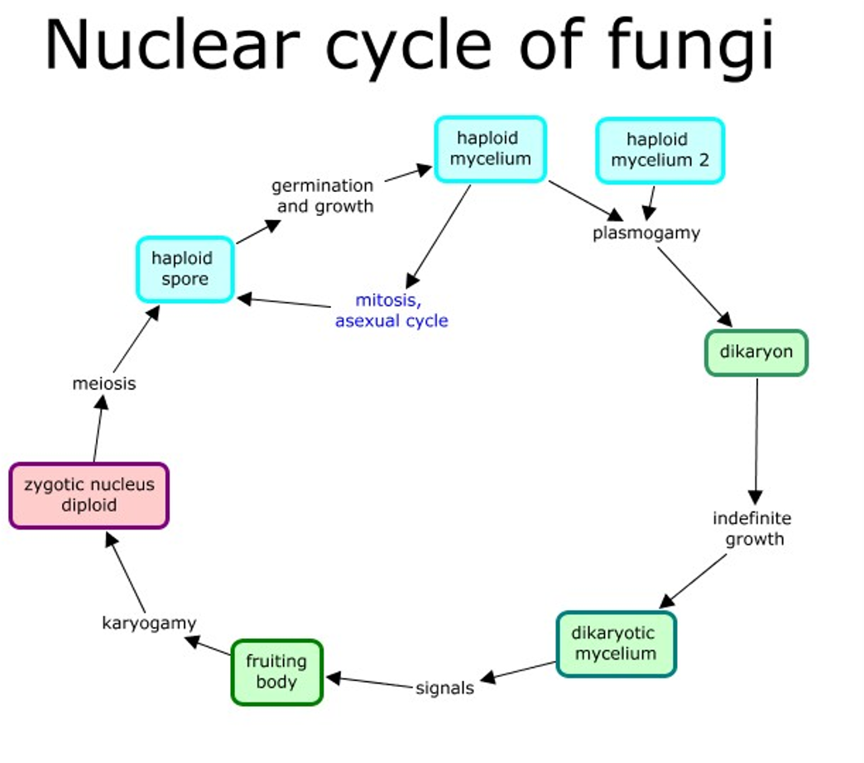
Figure 6.1. General life cycle of fungi. From Tom Volk

All fungi begin life as a spore (Figure 6.1). The spore can then germinate into either a hypha or a yeast, depending on the species. For some dimorphic species (capable of growth as a yeast or a filamentous mycelium), environmental interactions will determine their growth form. If filamentous, the hyphae will grow, secreting extracellular enzymes (exoenzymes) into their environment, allowing the fungi to penetrate and grow through substrate, in three dimensions. Most fungi that grow from spores possess genetically uniform nuclei (an exception to this may be the multinucleate spores of the Glomeromycota). When a hypha has only one type of nucleus in the cell, it is called monokaryotic.

Homothallism and Heterothallism
Heterothallism: These fungi need another individual to mate with sexually. When two compatible hyphae (fungal threads) meet, they fuse, and their nuclei combine, but each keeps its own genetic material. This results in a dikaryoticmycelium (with two separate, genetically distinct nuclei). When the environment signals, the two nuclei fuse (karyogamy), and sexual reproduction takes place, creating spores with a mix of genetic material from both parents. This process encourages genetic diversity. Heterothallic fungi can also reproduce asexually to spread quickly and find a mate when needed.
Homothallism: Fungi that are homothallic can mate with themselves, meaning they don’t need another individual for sexual reproduction. The process is similar to heterothallic fungi in that the nuclei fuse and then undergo meiosis to create sexual spores. However, self-mating reduces genetic diversity compared to mating with a different individual. This can lead to more uniform offspring, which could be beneficial in stable environments, but it may limit the fungus’s ability to adapt to changes or new challenges.
Benefits and Drawbacks:
- Heterothallic fungi get more genetic variety by combining the genomes of two different individuals, which helps them adapt and evolve. But they need to find a mate, which might be tricky in some environments.
- Homothallic fungi, on the other hand, can reproduce alone, which can be an advantage in environments where mates are scarce. But, because they’re reproducing with themselves, they don’t get as much genetic variation, which might make them less adaptable.
Dikarya is a group made up of Basidiomycota and Ascomycota (which includes many molds). The key feature of these fungi is the dikaryon stage. This means that after two compatible haploid (1n) individuals meet and fuse their cell membranes (a process called plasmogamy), their nuclei don’t immediately fuse. Instead, the two nuclei stay separate for a while, and this results in a dikaryon (n+n), meaning there are two distinct nuclei in the same cell. This is different from other organisms in the Opisthokonta group, like humans, where after plasmogamy, the nuclei fuse right away to form a diploid (2n) cell.

Basidiomycota
In Basidiomycota, the life cycle starts with a haploid spore that grows into a haploid hypha. For heterothallic (needing a mate) fungi, these hyphae will search for a compatible partner. When they find one, the hyphae fuse (called plasmogamy), but instead of combining into one single nucleus right away, the nuclei stay separate, creating a dikaryoticstate. This means there are two genetically distinct nuclei (n+n) in each cell, and this state is maintained by a dolipore septum—a kind of "gatekeeper" that prevents the nuclei from mixing.
As the hyphae grow, the fungus waits for the right environmental conditions to form a fruiting body (also called a basidiome), which is what we recognize as a mushroom. In the fruiting body, specifically in the lamella (the gills of the mushroom), the two nuclei finally fuse to form a diploid zygotic nucleus. This is the only diploid stage of the lifecycle. After this, meiosis happens, resulting in four genetically unique daughter nuclei. These become spores that are released from the tips of basidia (the club-like structures on the gills). Some Basidiomycetes can also reproduce asexually, creating spores without needing a mate or forming a fruiting body.

Ascomycota
In Ascomycota, the life cycle begins similarly with a haploid spore that grows into mycelium. For heterothallic species (again, needing a mate), when compatible hyphae meet, they fuse to create dikaryotic hyphae. Ascomycetes form septa(walls between cells), but unlike Basidiomycota, their septa have pores that allow the movement of nuclei and organelles. This results in a lot of nuclear movement, especially in the growing tips of the hyphae.
For sexual reproduction, specialized structures called ascogonium and antheridium form. The antheridium transfers nuclei into the ascogonium, and the two nuclei eventually fuse (karyogamy), creating a diploid zygote. This zygote undergoes meiosis, producing four unique nuclei. These then divide again by mitosis to form eight spores in a specialized cell called the ascus (plural asci).
Ascomycota also produce asexual spores, which are more common and are produced via mitosis. These spores (called conidia) are haploid and are made on specialized structures called conidiophores (Fig 6.2). These conidiophores can look different depending on the species and are a key feature for identifying different species of ascomycetes.

Key Differences:
- Basidiomycota typically form fruiting bodies (like mushrooms) and can undergo both sexual and asexual reproduction, with the dikaryotic stage lasting a long time.
- Ascomycota, while also capable of sexual reproduction, are more likely to reproduce asexually and produce large numbers of conidia quickly, which is why molds often spread fast.
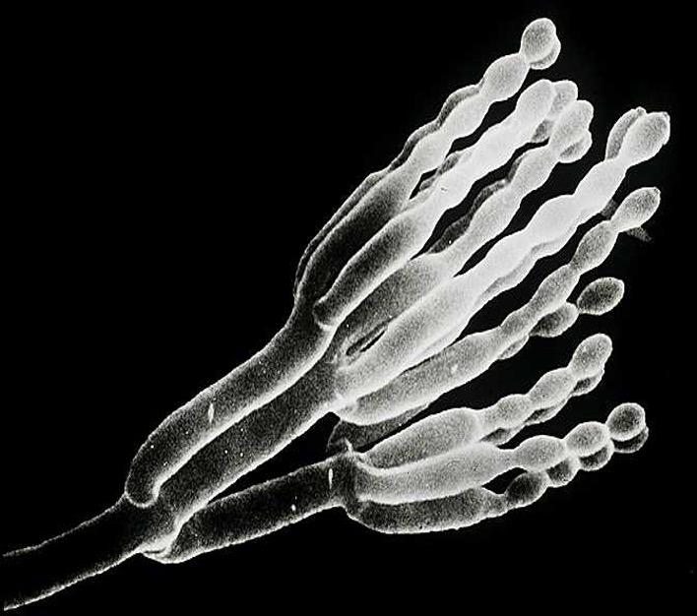
Fig. 6.2. Conidiophore producing asexual spores. From Tom Volk

It is important to understand that some filamentous fungi can produce asexually in addition to sexual reproduction. Understanding how particular fungi grow and reproduce can help us better develop sustainable treatments to protect crops and animals against certain pathogens.

Vegetative Compatibility
The concept of vegetative compatibility in fungi provides an additional layer of complexity to their reproductive and growth strategies. It goes beyond the simple mating type compatibility and involves a self/self-recognition system that governs hyphal fusion (anastomosis) and plasmogamy.
Fungi that possess vegetative compatibility can form complex, interconnected mycelial networks by fusing hyphae from the same or genetically similar individuals when they come into contact. This self/self-recognition system allows the fungus to build a more efficient, reticulated (net-like) structure. These networks offer several benefits:
- Improved Resource Acquisition: The mycelial network can spread more widely, reaching new resources, and allowing the fungus to more effectively exploit its environment.
- Increased Cytoplasmic Flow: The fusion of hyphae creates pathways for better flow of cytoplasm and nutrients throughout the fungal body.

Genetic Diversity
While vegetative compatibility might sound like a mechanism for self-fusion, it also helps increase genetic diversity. Here’s how:
- When two genetically distinct individuals (from different vegetative compatibility groups) come in contact, their hyphae may fuse, even if they are from different genetic backgrounds.
- If they are not compatible (i.e., their genotypes are sufficiently different), the bridge of cells connecting the two hyphae is often destroyed by programmed cell death. However, if the individuals are compatible, the fusion allows cytoplasmic exchange between the mycelia, which can include genetic information, endosymbionts, or even viruses.
This type of system is called self/close-enough-to-self recognition, meaning that fungi recognize when they are genetically similar enough to merge and share resources, but not so genetically distinct that they risk incompatibility. When fusion is successful, the resulting mycelium can contain a variety of heterogeneous nuclei (multiple different nuclear genotypes), allowing for multinucleate states. This means that even within one fungal body, different parts of the mycelium might have different genetic compositions, a process that enhances the fungus's adaptability.

Implications for Adaptation
- Increased Adaptive Ability: The diversity of nuclei within a single mycelium gives the fungus a wider range of genetic traits to draw upon, making it more adaptable to changing environmental conditions. For example, if one part of the mycelium encounters an unfavorable environment, another part (with a different genetic makeup) might fare better.
- Sectoring: When growing in a controlled environment, like a petri dish, a phenomenon called sectoring can occur. This means that different sections of the mycelium might show variations in phenotype, based on the different nuclear genotypes present. This can be a strategy to increase survival chances under fluctuating conditions.
- Nitrogen and Phosphorus Storage: In multinucleate, coenocytic fungi (those with continuous cytoplasm and multiple nuclei), the presence of extra nuclei may serve as nutrient sinks, especially for nitrogen and phosphorus. These nutrients can be stored and then used as needed, which is helpful when resources are limited. This process may even occur through autophagy, where the fungus breaks down its own parts to recycle materials.

Vegetative compatibility allows fungi to form extensive mycelial networks by fusing hyphae from genetically similar or compatible individuals. This system not only promotes growth and resource acquisition but also enhances genetic diversity and adaptive potential. The ability to have multiple genetic backgrounds within a single mycelium increases a fungus’s fitness by providing flexibility in different environments, and it can even help store essential nutrients like nitrogen and phosphorus for future use. Essentially, this mechanism allows fungi to self-organize and adapt in ways that give them a greater edge in surviving and thriving in diverse or changing environments.
Yeasts:
Yeasts are fascinating single-cell fungi, primarily belonging to the Ascomycota group, although some Basidiomycota species, like Cryptococcus neoformans (a human pathogen), also exhibit a yeast-like growth form. Other fungi can grow both fiamentous and yeast morphologies, depending on the environment (referred to as ‘dimorphic’). Yeasts are incredibly versatile organisms, both in their biological characteristics and their wide-ranging applications.

Reproduction of Yeasts
Yeasts can reproduce asexually and sexually:
- Asexual Reproduction (Budding):
  - The most common form of asexual reproduction in yeasts is budding. In this process, a parent cell produces a smaller, genetically identical daughter cell by pinching off part of its body. This method can continue indefinitely, given the right conditions (e.g., nutrient availability, temperature).
  - Budding often results in asymmetric division, with the daughter cell typically being smaller than the parent cell at first. Over time, asymmetrical budding or stressful environments can cause the yeast cells to age and senesce (enter a state where they stop reproducing), producing a finite number of daughter cells.
- Sexual Reproduction:
  - Yeasts can also reproduce sexually, which involves genetic recombination. In this process, two compatible haploid cells (spores) fuse, resulting in the formation of a diploid zygote. This allows for genetic variation, which can be beneficial for adaptation to changing environments.
  - The sexual life cycle in yeasts can include the formation of structures like ascus (in Ascomycota), where spores are formed after meiosis.

Applications of Yeasts
One of the most intriguing applications of yeasts is in bioengineering. For example, yeasts have been used to produce cannabinoids like CBD and THC. Scientists can insert genes responsible for CBD/THC synthesis into Yarrowia lipolytica (a yeast species), allowing the yeast to produce cannabinoids when cultured in a sterile medium. The cannabinoids are then exuded into the liquid, which can be harvested and purified. This approach is significantly faster than growing cannabis plants, making it a promising avenue for efficient cannabinoid production.

Yeast in Cannabis Production
- The genetic engineering of yeasts to produce cannabinoids is one of the innovative ways in which biotechnology is being used to improve the production of valuable compounds. This process reduces the time and resources required to produce cannabinoids compared to traditional agricultural methods.
- Yeasts, with their ability to multiply rapidly and in controlled conditions, offer a scalable and sustainable method for cannabinoid production, especially in research or industrial contexts.

The “Lower” Fungi
The term "Lower Fungi" refers to fungal groups that lack the dikaryon formation seen in the Dikarya (Basidiomycota and Ascomycota). The "lower" designation does not imply that these fungi are less important or evolutionary "primitive," but rather that they lack certain features like the dikaryotic life stage. All organisms, including these fungi, have evolved for the same duration from a common ancestor, and the term "lower" is historical rather than evolutionary in value. A more accurate term might be "more- or less-derived" from an ancestral state.

Glomeromycotina and Mucormycotina
- Glomeromycotina (Arbuscular Mycorrhizal Fungi):
  - These fungi are crucial for forming arbuscular mycorrhizae, a symbiotic relationship with plant roots, primarily aiding in nutrient uptake.
  - While sexual reproduction has been debated, asexual reproduction is more commonly observed. This involves the production of spores that are used for fungal dispersal.
  - Chlamydospores, thick-walled, asexual spores, allow these fungi to survive in harsh conditions. These spores may contain multiple nuclei and require plant root signals for germination.
- Mucormycotina:
  - Mucormycotina fungi are typically dispersed by asexual spores but can also reproduce sexually via the formation of zygospores. This sexual process involves the attraction of compatible mating types using volatile chemicals, leading to the formation of a zygosporangium.
  - These fungi are considered important mycorrhizal fungi and have recently gained attention for their ecological roles.

Chytridiomycota
- Chytrids represent one of the most ancestral fungal life cycles. They produce zoospores, which are motile spores with flagella that can swim in aqueous environments. These zoospores can be haploid or diploid depending on the species.
- Male and female gametes are produced in some species, with both being mobile, while in others only the male gametes are motile.
- Interestingly, some Chytrid species can be cultured using sterile hemp seeds as bait.

Oomycota (Water Molds)
- Oomycota (often called water molds) are not true fungi but are eukaryotes classified as heterokonts. They are more closely related to diatoms and brown algae than to true fungi.
- Asexual reproduction in Oomycota involves the production of zoospores (flagellated spores) or sporangiospores, which can swim to infect new host plants. They can also form cysts for long-term survival.
- Sexual reproduction in Oomycetes involves the formation of oogonia (female) and antheridia (male), which fuse to form diploid oospores. These oospores can infect new plants and begin the cycle again.

Fungi Imperfecti (Deuteromycota)
- Deuteromycota (or Fungi Imperfecti) are fungi that only reproduce asexually, often through the formation of conidia or spores. These fungi do not have a known sexual stage and are considered “imperfect” because they lack observed sexual reproduction.
- Though they lack sexual reproduction, genetic novelty can still arise through mechanisms such as vegetative compatibility or the parasexual cycle.

Actinobacteria (formerly Actinomycota)
- Actinobacteria are a group of gram-positive bacteria that resemble filamentous fungi. They are prokaryotic organisms and reproduce by forming arthrospores or conidia rather than through sexual reproduction.
Conclusion
Fungal reproduction is varied, with many successful strategies having developed that can seem quite different from sex among animals with which many readers are more familiar. Now that we have a better understanding of how fungi grow and reproduce we will look at some specific examples of how particular fungi interact with the Cannabis plant.

In summary:
- All fungi reproduce via spores
- Most fungi must fuse with a compatible mating type before producing a fruiting body
- Some fungi can produce both sexual and asexual spores

